
Department of Mechanical Engineering

EMCH 368
MECHATRONICS

Lab 09
LED Classification

Last Edited: 07/11/24 by Tyler Russo

Exercise 1: Building the Circuit:
This lab uses MATLAB to classify an LED as red or green. To do this, a linear classifier was programmed to develop a way to differentiate the two LEDs within MATLAB. Once a method is obtained, we use a microcontroller to deploy the classification method. It sounds complicated, but basically, we used MATLAB to figure out the difference between red and green LEDs, and based on the difference recorded, we then incorporated this into an Arduino program.

Materials:
● 1 set of long red and black jumper wires
● 2 220-ohm resistor
● 1 Red & 1 Green LED
● 2 potentiometers

Build the Circuit:
For this lab, you need to:
- Connect two potentiometers to analog pins
- Connect one red LED and one green LED to digital pins. Remember to ground the LEDs with resistors.
Writing the Code (Part 1):
Open MATLAB to write the training portion of this code. This code's goal is to create a way to classify the color of an LED on the microcontroller. Once the MATLAB script is run, a graph will be output which will give us a way to distinguish between the LED’s based on the input voltage. (I am using R2020b, however, no specific add-ons are required so should work for most recent distributions ~ >2017)
This will simply clear any script or workspace you have set up within MATLAB, allowing you to start the new program from scratch.

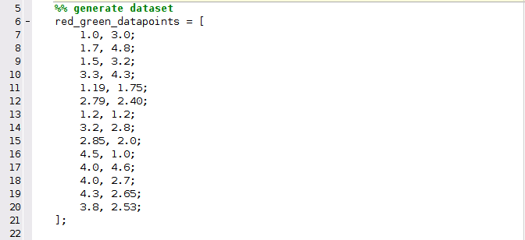

Within this code, example data points that represent 2 different voltage values were created within this matrix. This gives the MATLAB program data to sort through and classify as either “red” or “green” in this case.

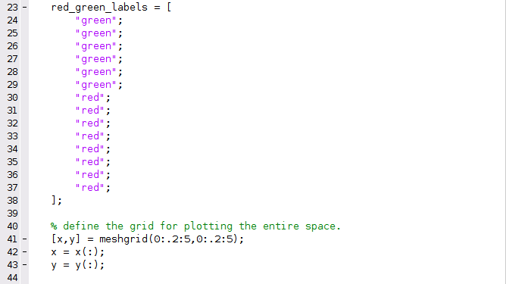
This section labels the previously input data points as either red or green on the graph we will have output. To output this graph, the ‘meshgrid’ function generates a grid of points covering the voltage space from 0 to 5 in both x and y directions. This grid will be used for visualizing the classifier's decision boundaries.

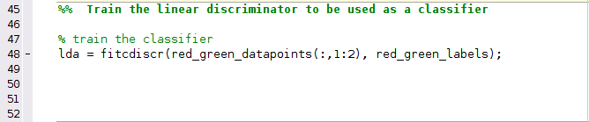
The fitcdiscr() function trains a linear discriminant analysis (LDA) classifier using the provided data points and labels. LDA finds a linear combination of features that best separates the classes (in this case, "red" and "green"). The first argument of the fitcdiscr() function is described as either a predictor, feature or attribute, while the second argument is a response or label.
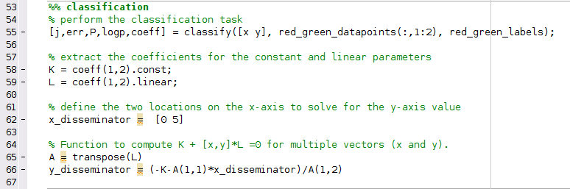
This is the classification portion of the code. The syntax of the first function can be seen as classify(sample, training, group). A few things to keep in mind with the classify function is the sample and training data sets must be matrices with the same number columns. Inversely, the training and group data sets must have the same number of rows. [j, err, P, logp, coeff] is a built in MATLAB function to obtain more data using classify. Err returns an estimate of the error rate based on misclassification of the training data. P returns a matrix posterior of estimates of the posterior probabilities that the nth training group was the source of the i’th sample observation. Logp returns a vector containing estimates of the logarithm of predictive probability density of the example observations. Lastly, coeff returns an array containing coefficients of the boundary curves between pairs of groups.
After the classification, an x_disseminator and a y_disseminator were determined. The output of each disseminator is a range on the x or y-axis and with these, a line can be drawn which will determine if a data point represents red or green.

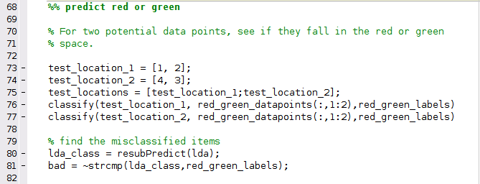
Two potential data points are classified to see if they fall within either red or green. With test_location_1 and test_location_2 classified, the resubPredict function was used on the previously classified data set lda, which simply returns the predicted label for the training data. The newly classified test locations stored in the array lda_class was then compared to red_green_labels using the ~strcmp function, which compares strings. This is done to find any misclassified data, such as if a data point was labeled red, but placed in green, the strings that label the points would not be equal and signal a misclassification.

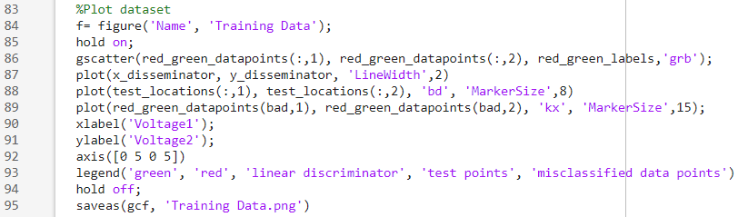
This section of code will provide information to the grid we created previously. While it is a bit of code, it is not necessarily technical, but for more in depth plotting help, you can search “plot” in MathWorks and take the whole day seeing your options.

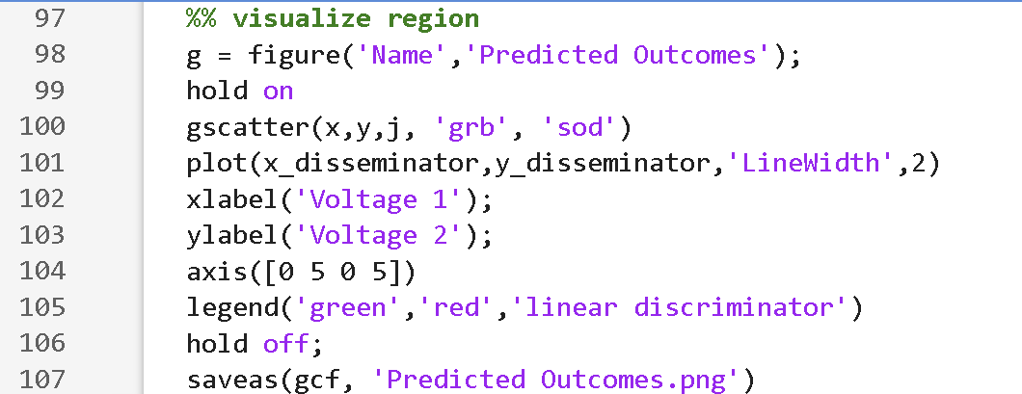
This visualization section gives us the outputs seen below; the graph representing the training data classification period as well as a graph of the predicted outcomes based on the linear model developed.
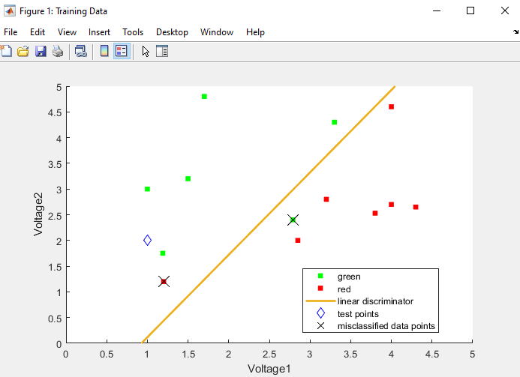
Figure 1: Training Data Classification Graph
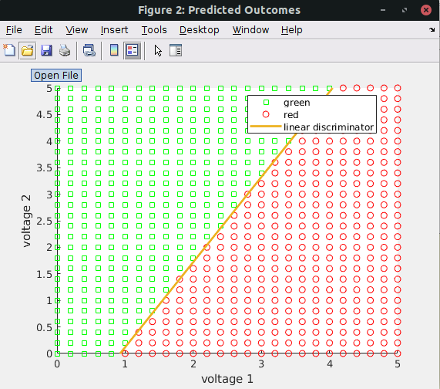
Figure 2: Predicted Outcomes Graph
The output of the Matlab script will give you two graphs, one depicting the training data being classified and the other the overall predicted outcomes based on the classifier. The graph showing the training data also includes the misclassified and subsequently excluded data points that were incorrectly labeled as either red or green.
The main objective of these graphs is depicted by the linear discriminator, which is the line between the points (0,-1.4846) and (5, 6.5289), or the values obtained and labeled as our x and y disseminators from the MATLAB script. To classify an LED on our microcontroller , we will use the equation of a line, y=mx+b, where m is the slope of the linear discriminator, b is the y-intercept of the linear discriminator, x is voltage 1 from the figure above and y is voltage 2. We can then program this equation into microcontroller when we are ready to deploy this classifier.
Writing the Code (ARDUINO IDE) (Part 2):
- Declare the variables for the digital and analog pins
- In void setup, declare the pins as either an output or input. Begin the serial communication as well.
- In void loop, you will need to read the potentiometers, then multiply the values by 5 / 1023. This converts the output into volts.
  - Show in the serial monitor what the output of both the potentiometers are before and after the multiplication. (Before = analog voltage, After = voltage)
- Finally, use the slope and y-intercept obtained from the MATLAB code to create an if and else statement that turns on the green or red led lightbulb depending on what the voltages are from the potentiometers.

Lab Grading Rubric:
- Circuit fully built (10 points)
- Training data graph (15 points)
- Predicted outcomes graph (15 points)
- Comprehension Questions (10 points)

